1) Anatomy of the Brain

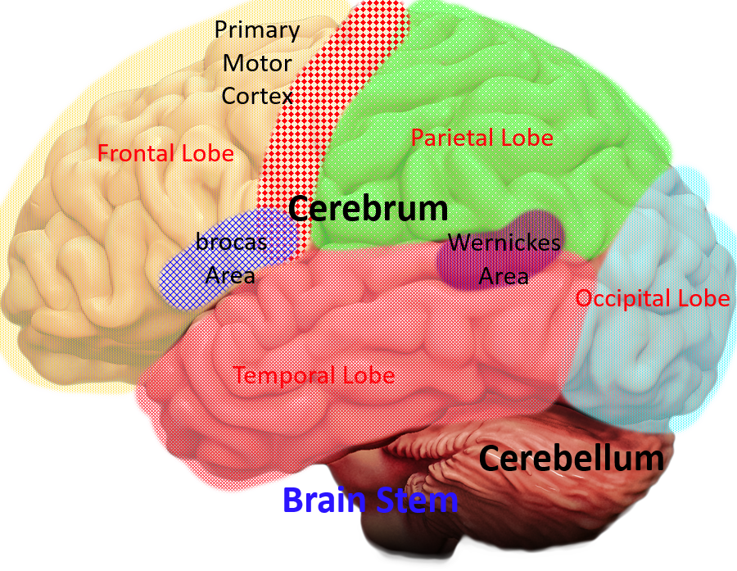

Source: https://www.brainline.org/sites/all/modules/custom/bl_brain/images/brain-lateral.png

There are many parts of the brain, some of the most important parts are located within the Cerebrum: which is the largest part of the brain. It contains one. The Frontal lobe: this part is responsible for movement, expressive language and for cognitive skills like self-monitor, plan, and organize, it is where Broca’s area is, controlling Language comprehension. 2. The Primary motor cortex is also here, controlling motor functions in the body, like movement. The Parietal lobe is for the senses: including, but not limited to taste hearing sight touch and smell. 3. Occipital lobe: covers visual perception, color, motion, and form. And finally, 4. Temporal lobe: Wernicke's area is, this part covers spoken and written language comprehension. This is where Wernicke's area is, this part covers spoken and written language comprehension. There are also smaller parts of the brain like the Cerebellum: holds more than half of the neurons in the brain and covers a wide range of functions but primarily balance, and the Brain stem; is important for regulating most of the essential functions of the body like breathing

2) Anatomy of the Ear

Source: https://commons.wikimedia.org/wiki/File:Anatomy_of_the_Human_Ear_blank.svg

outer ear the outer ear channels all the sound waves deeper into the ear, it contains the pinna which also is most responsible for channeling the sound. Also present is the lobe which helps maintain balance and temperature of the ear. Finally, in the outer ear is the ear canal, this part is the entrance for soundwaves into the middle ear. The middle ear contains ossicles which are the Malleus (connects the tympanic membrane to the anvil) Anvil (which transfers the signal from the Malleus into the stirrup) and the Stirrup (which sends that signal into the middle ear). Also in the middle ear is the eustachian tube, the function of this part is the equalize the air pressure in the middle ear and the outside. Finally in the inner ear there is the cochlea which senses sound and changes sound waves into a signal that the brain can read and sends them through the auditory nerve into the brain. There are also semicircular tubes that are responsible for balance.

3) Anatomy of the Vocal Tract

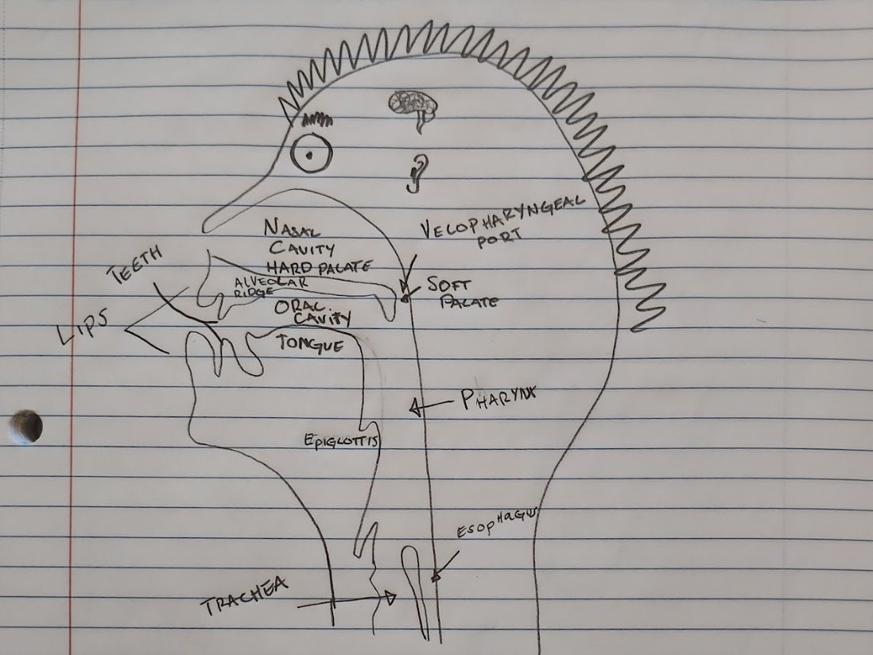

The /p/ sound is Bilabial, it is produced from connected the lower and upper lips and making a plosive sound. In the IPA, its symbol is p. the soft palate closes and just the oral cavity and lips are used to build pressure, and then release it.

The /k/ sound is Velar, it is produced from putting the tongue to the velum and making a plosive sound. In the IPA, its symbol is k. the soft palate closes and the tongue presses against the velum to build pressure, and then release it.

4) Anatomy of the Larynx

Source: <https://commons.wikimedia.org/wiki/File:Larynx_Anterolateral_View_Unlabeled.jpg>

Trachea is also known as the windpipe and carries oxygen rich air into your lungs and carries carbon dioxide waste out of the lungs. cricoid cartilage provides a location for the cricoid muscles to connect to, these muscles control the vocal cords by changing their lengths. thyroid cartilage supports and protects the larynx, helps create the sound of a person’s voice. Laryngeal Prominence has no definite function but does provide some sort of protection. thyrohyoid membrane connects the thyroid cartilage to the hyoid bone, helps in swallowing. Finally, the hyoid bone carries the weight of the tongue and plays a vital role in swallowing.

5) Current IPA chart

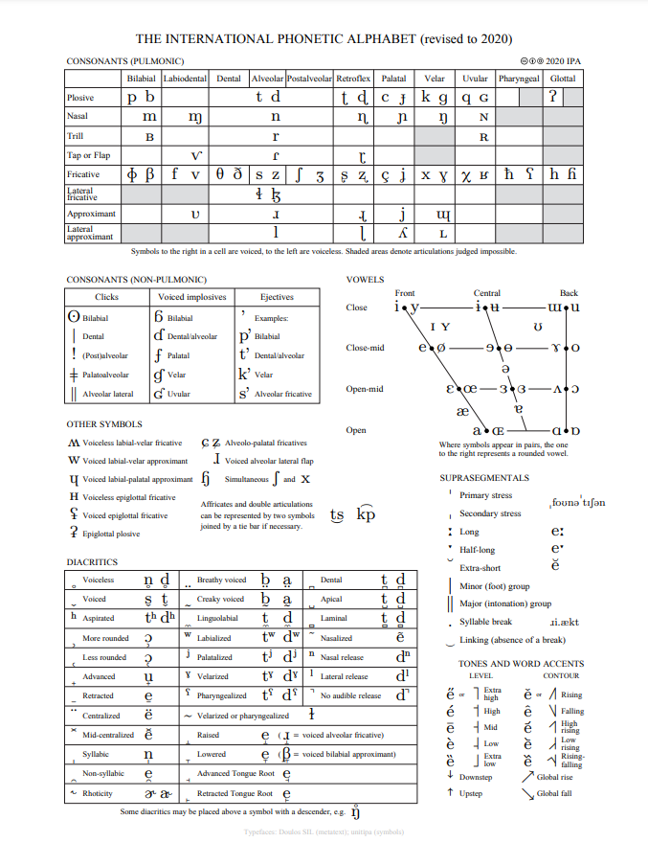

Source: <https://commons.wikimedia.org/wiki/File:IPA_chart_2020.pdf>

The IPA stands for International Phonetic Alphabet, it is based primarily on the Latin alphabet and is a standardized list of sounds that languages use. This alphabet is used by a broad range of people to show exactly which sounds they are trying the convey. The IPA is a strong resource to use when learning a new language, writing words down in the IPA also show very easily which words rhyme or not. The IPA also describes where in the mouth sounds are made. There are multiple charts for consonant pulmonic, consonant nonpulmonic, vowel, and diacritics. If there is a sound that a human can make with its mouth than it is on this chart.

Last updated: 9/3/22 – v1

6) 1 Speech Disorders

a. Pick any speech order we talked about in class

Apraxia

b. Include a definition (what is this speech disorders?)

Apraxia is defined by having problems with planning how to move the muscles involved with speech

c. Include the etiology (what is the origin/cause of this disorder?)

Apraxia is caused by a problem in the brain, specifically Broca’s area.

d. Include symptoms (how does this disorder manifest?)

This disorder’s symptoms include difficulty changing from one sound to another in speech production, making the wrong sound, and non-fluent speech.

7) 1 Language Disorder (same instructions as the speech disorder)

Autism Spectrum Disorder (ASD) is a language disorder that is present in 1-2% if children, it is characterized by their differences in how they communicate, learn, and behave. The cause of ASD is still unknown and is not diagnosed through typical means. Symptoms include less social interaction, strong focus on few things, and repetitive behaviors. The actual range of symptoms is extremely broad.

a. Pick any speech order we talked about in class

Dysarthria

b. Include a definition

Dysarthria is characterized by problems executing the movements required to make the correct sounds in speech, meanwhile the mental planning is correct.

c. Include the etiology

This disorder is commonly caused by nervous system disorders that cause facial muscle weakness

d. Include symptoms

Symptoms of Dysarthria include Voice disturbances, Imprecise articulation, Slow effortful speech

8) Possible Careers

a. Pick one career in communication disorders (SLP, SLP-A, audiologist,

professor/researcher)

b. Write a short paragraph what you must do to become your selected career

Audiologist

The road to becoming an audiologist is not a short one, it starts with completing a bachelor's degree. Although there is no specific degree that Audiologists need, a common one that undergraduate students choose is communication disorders or sound engineering. From there, perusing an AuD, PhD, or an AuD/PhD combination degree. The student must also complete and externship year, this is a year of supervised clinical experience. There is also a test that is required to pass called the Praxis Audiology, next a license is required, and each state has different requirements. While it is not required, getting a certification can help prove their proficiency.

Become an audiologist. (2022, June 07). Retrieved November 30, 2022, from <https://www.audiology.org/careers/become-an-audiologist/#:~:text=Those%20who%20pursue%20the%20profession,between%20eight%20to%20ten%20years>.

9) Reflection

Write a 300-500-word reflection about one of the following (pick one topic, state your

topic, and then write your reflection about it).

iii. What you have learned in this class (e.g., mention something that stood out to

you, that you found interesting, that you could use in other classes, that is

relevant to your life, etc.; think about what and why)

Throughout this class, many interesting things stood out to me. If I were to pick one, it would be the effects of a stroke on the brain. The reason this stuck in my head is that my aunt had a stroke less than a year ago. Some of the things we were going over in class were things that happened to her not too long ago. The topic of apraxia was quite interesting, it was like I was learning about my aunt, and helped me understand what she is going through. More with how strokes affect communication through dysarthria, it was interesting how even though they know how to say the words, they just will not come out correctly because of muscle weakness and paralysis. I wondered what I would do if I were in the same position, it certainly puts into perspective the struggles that they go through every day. It helps me be thankful for what I have, and at the same time makes me admire their perseverance.

Another interesting effect was when the stroke patient had fluent aphasia, this is when the patient speaks at normal speed and thinks nothing is wrong, but their speaking is incoherent, and they do not understand what is being spoken to them. It is fascinating that they do not perceive any problem, it is almost scary. If you never know something is wrong but people keep telling you that you are not understand, but you cannot even understand that correctly. I wonder how to effectively communicate with patients like that. With this information from class, I think the only way I can use this is to be more empathetic to people that are affected by these disorders.

I do hear that people sometimes get better from these, but it also leads me to wonder how these parts of the brain are optimized to do these specific tasks so well because I always thought each neuron was built the same. I would liken it in terms that make more sense to me as a computer engineering major, like a graphics card doing graphics calculations extremely fast, but then general calculations slowly compared to the regular CPU, and even things like sound cards or internet cards, just really specialized components that do one task well, even though they are all just made up of transistors and not much else.